Class Diagram

The follow diagram shows the class structure of the system to be implemented. It details the different classes and their respective attributes and methods. The attributes are the data that will be stored. The methods are the operations that can take place with that specific class. Diagram 1 was mainly built using prototype analysis. By looking at the prototypes, we were able to create the respective class structure necessary. Most of this diagram revolves around administrators and their abilities to manage different classes. It also features the users and what they can do in the system.



Diagram 1

Database Design and Data Definitions

The following diagram shows the database design for the system to be implemented. This involved taking the class diagram and cutting some of it down to eliminate any repetition and other related flaws. Most of the data will be stored as strings with relatively small character counts. Some of the attributes will have to support high character counts though, as there are some that will contain paragraphs.



Diagram 2

Windows Navigation Diagram

The following diagram depicts the screens needed when interacting with the system. This is a helpful diagram that maps out all the routes users will take when using the system.



Diagram 3

User Interface and Screen Layouts

Figure 1 below shows what the community landing page might look like. Considering there was not an existing one on the current R&I website, we took a few liberties in putting what we thought should exist on the page.



Figure 1

Figure 2 below shows what an administrator might wee when creating, editing, or deleting a survey. The form offers many different types of questions, as well as a button to add more questions. The administrator basically has free range to go in and put whatever they need into the survey.



Figure 2

Figure 2 below shows what an administrator might see when creating an event. There are text boxes used to enter in event information. There is also a calendar that can be used to select the date. This will help with validation and make it a bit easier to select the date. There is also a section to add any relevant pictures that will show up in the events widget.



Figure 3

Figure 4 below shows what an administrator might see when editing and deleting an event. The first widget is used to quickly delete an event by clicking the ‘x’ button on the right-hand side of each event. The other symbol is used to edit an event. It will let the administrator edit the event title. The second image is the event editor. It is a more detailed editor that lets the administrator make sweeping changes to an event.



Figure 4

Figure 5 below shows what a new industry landing page might look like. Since there is not an existing page dedicated to industries on the site currently, we added what we thought would be beneficial for those stakeholders to see.



Figure 5

Figure 6 below is what a user would see if they were to fill out an industry request form. This is nearly identical to the existing IR form that exists on the site now. It didn’t need much changing.



Figure 6

Figure 7 below is what we imagine the new and improved landing page would look like. It has a new infographic that can be used to show off any interesting statistics. It also has a new widget used to search for connections. The events widget is an upgrade over the current one. This landing page also prominently features the R&I social media.



Figure 7

Figure 8 below shows what users might see when they look up the core research facilities that R&I offer. The current version is almost too minimal. This lets users scroll through existing facilities then click and expand the options to get more information. A link is provided that will take users to a separate page where all relevant information on each facility is located.



Figure 8

Figure 9 below shows what a new researcher landing page might look like. It includes a direct login to iRIS as well as a drop down for forms and a section for funding. It also includes infographics for each of the main facility types. At the base, there is a section for any relevant links



Figure 9

Figure 10 below shows how users can RSVP for an event as well as cancel for an event. If logged in, the user will simply click RSVP and that is it. The button will switch to say cancel to give them that option in the future. If the user has no account, they will be prompted to enter some information so that they can be added as an event attendee.



Figure 10

Figure 11 below shows what a new student landing page might look like. It features two sections for undergrad and graduate students that will contain any relevant information. It also has an events section and placeholders for videos. We saw that the current version included a few videos, so we wanted to ensure those were accounted for.



Figure 11

Create announcement

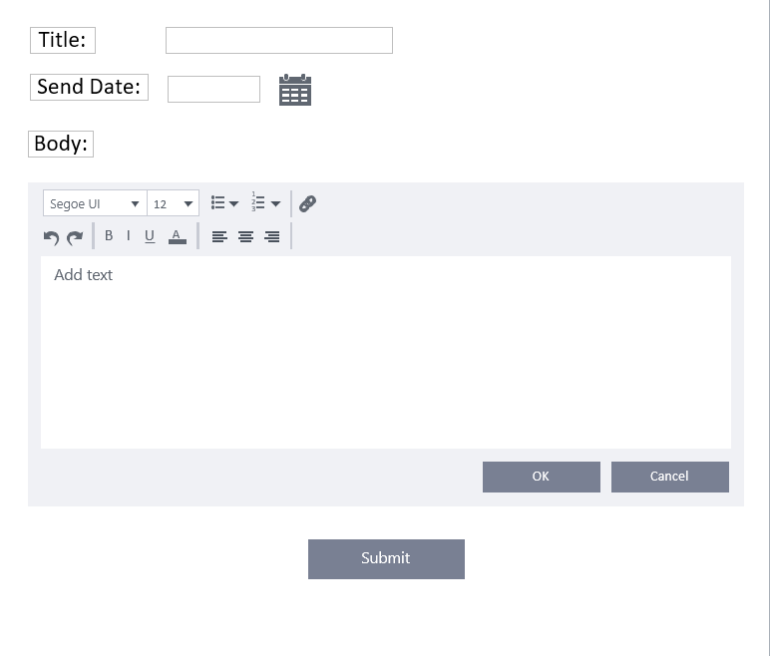

Create Grant

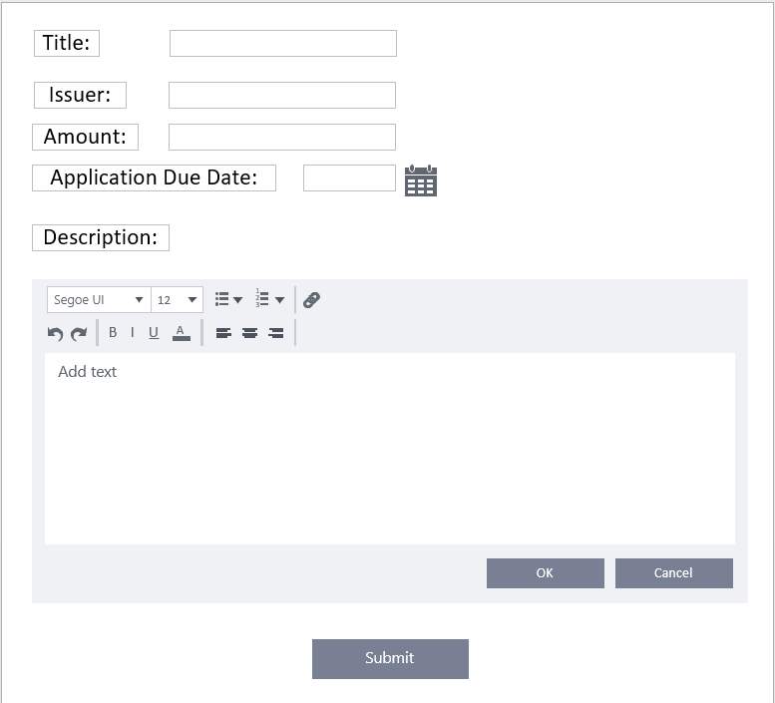

Create Newsletter

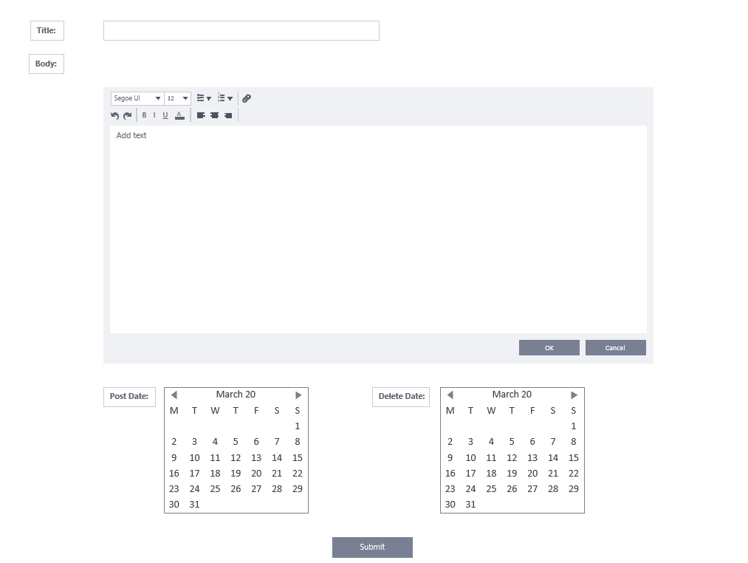

Create user profile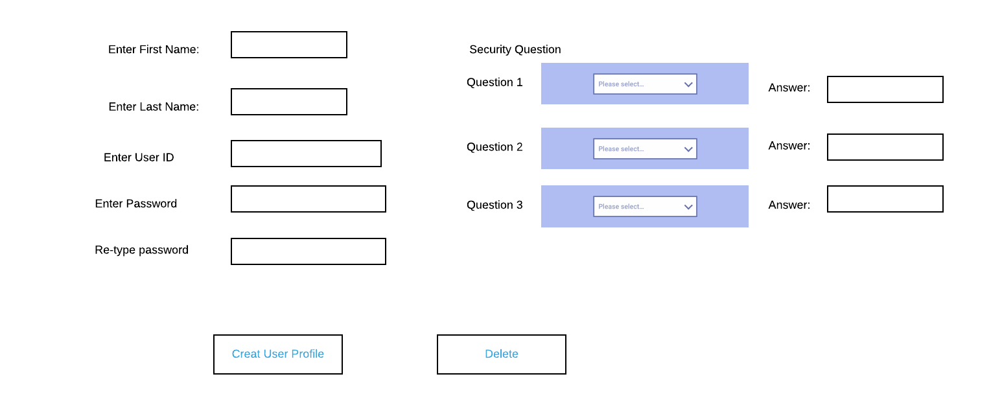

Contact us

This prototype demonstrates the contact us form that students and visitors can use to contact the Office of Research and Innovation.

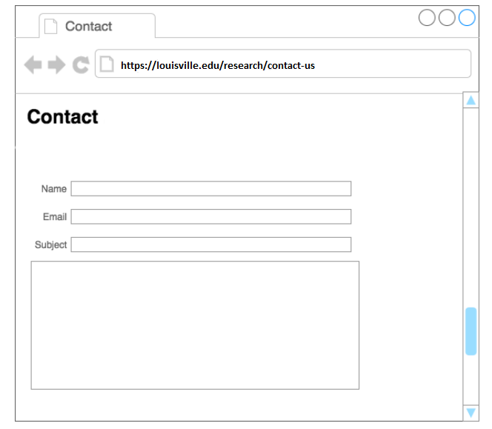

**Login**

This Prototype demonstrates what an administrator interface looks like when accessing the admin portal.

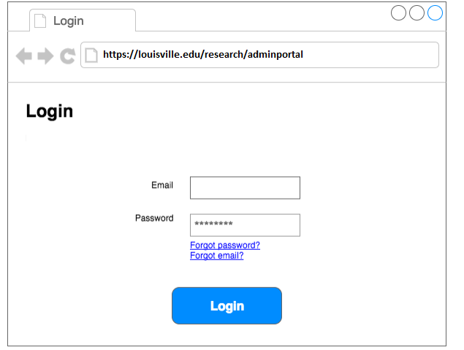

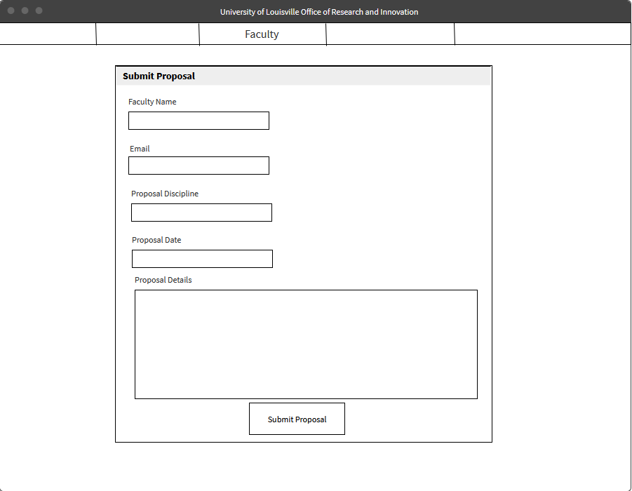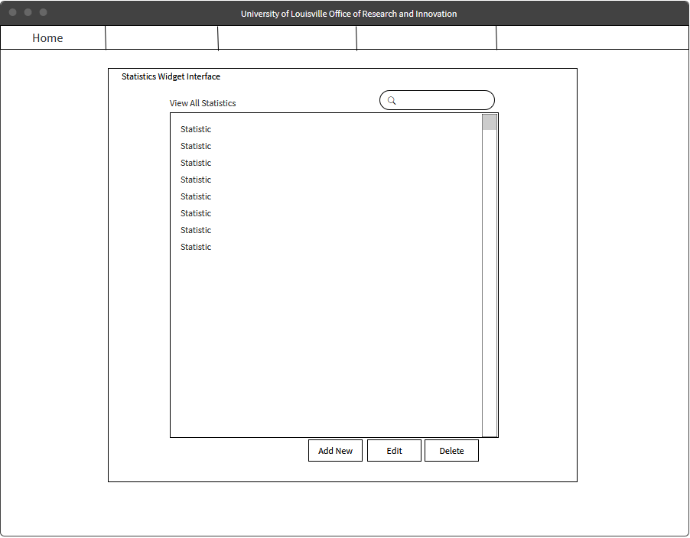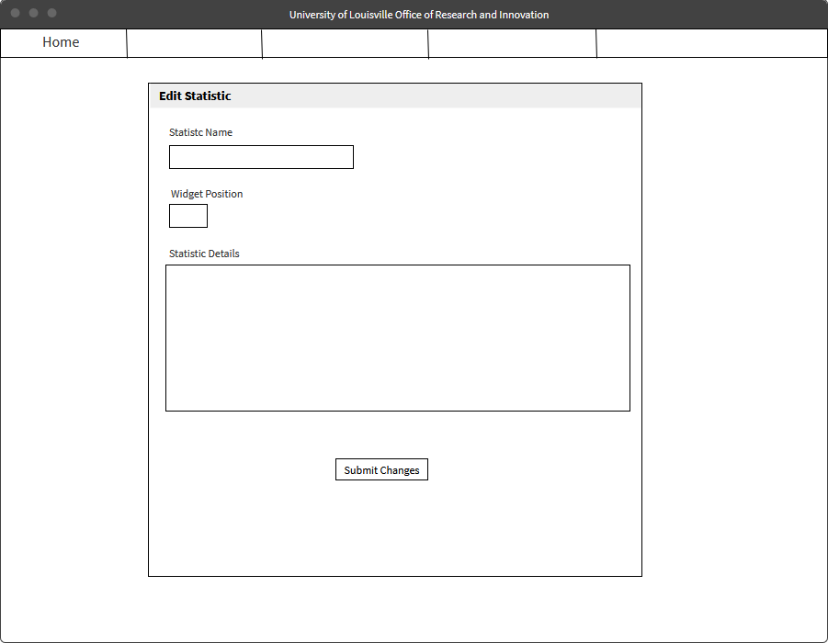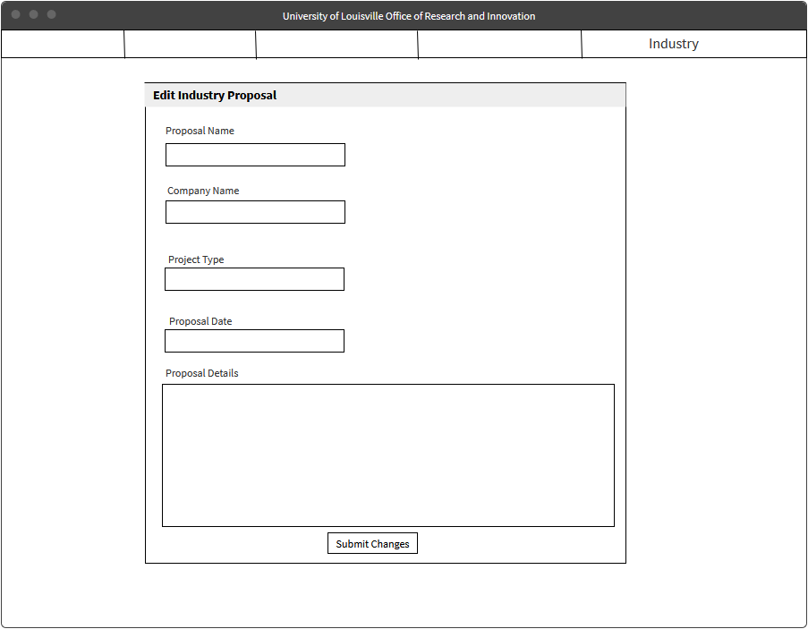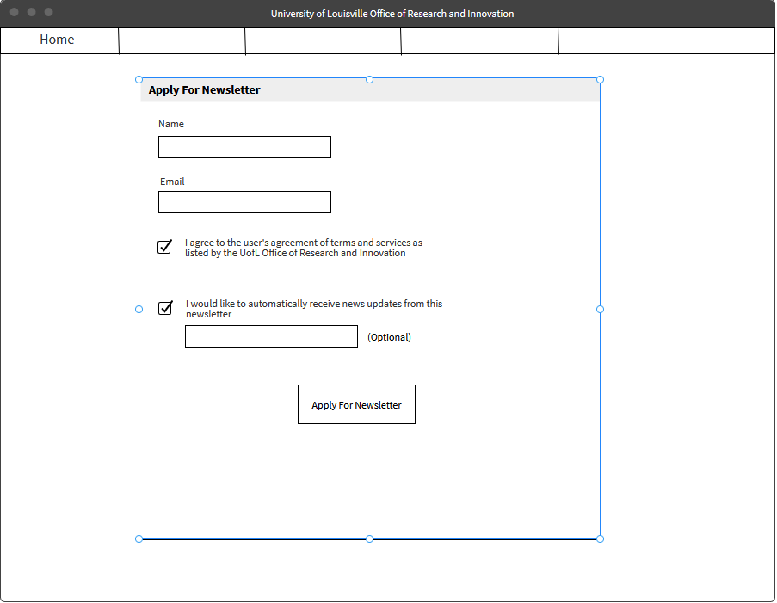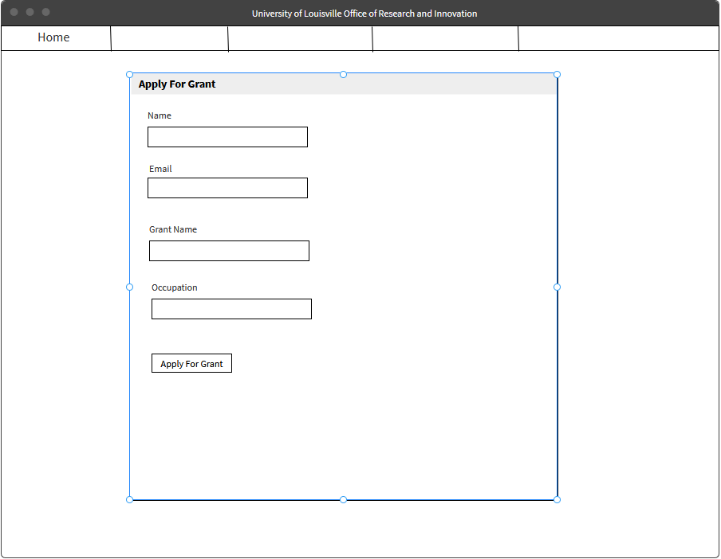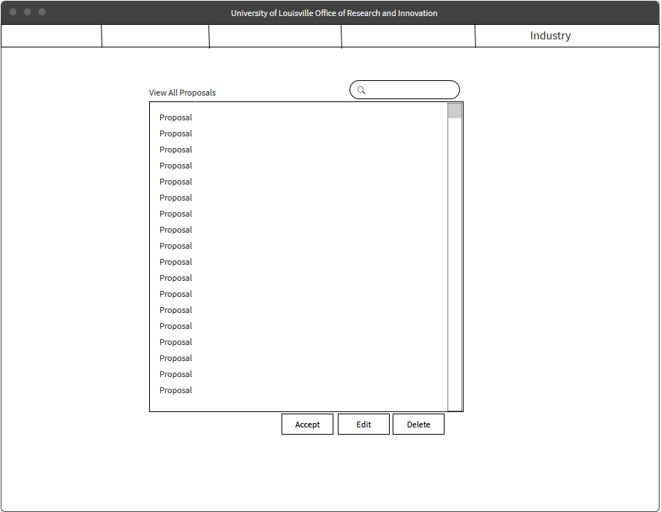

Gantt Chart

